**Critical Analysis on Andhra Pradesh RainFall (2023)**

**To:** Dr.B.Jogeswara Rao

**From:** T.Surya

**RollNo:** 2211CS010558

**Date:** 22/10/2025

**Subject:** **Analysis of RainFall in Andhra Pradesh (2023)**

**Dataset Description**

**Detailed Overview of the Data**

The objective of this project was to analyze rainfall patterns in various districts of Andhra Pradesh during 2023 using **PySpark** for distributed data processing and **Matplotlib/Seaborn** for visual analytics.

| **Metric** | **Detail / Value** |
| --- | --- |
| **Data Source/Agency** | IMD GRID MODEL |
| **Year of Data** | 2023 |
| **Total Observations** | 4745 records |
| **Overall Mean Rainfall** | 2.56998 mm |
| **Maximum Daily Rainfall** | 188.5136234 mm |
| **Data Quality** | Zero missing values were detected across all columns (4745 non-null counts in all columns) |

**Domain Description**

The dataset primarily contains geographical and meteorological variables. Key fields include State, District, Date, and the continuous variable Avg_rainfall (in mm). The domain focuses on understanding the distribution and variability of daily precipitation, which is critical for **irrigation planning** and **climate pattern prediction**.

**Observed Insights & Hidden Facts**

The analysis revealed significant spatial and temporal variations, successfully identifying the wettest/driest districts and key seasonal patterns.

**Key Findings (District-wise Rainfall)**

The districts were categorized based on the overall state average of $\approx 2.57$ mm.

* **Wettest Districts (Coastal Concentration):** The highest average rainfall was recorded in **West Godavari** ($\mathbf{3.418}$ mm), followed closely by East Godavari ($\mathbf{3.305}$ mm) and Visakhapatanam ($\mathbf{3.300}$ mm). These six districts were found to have above-average rainfall: West Godavari, East Godavari, Visakhapatanam, Krishna, Vizianagaram, and Guntur.
* **Driest Districts (Rainfall Deficit):** The lowest average rainfall was observed in **Anantapur** ($\mathbf{1.368}$ mm), followed by Kurnool ($\mathbf{1.518}$ mm) and Y.S.R. ($\mathbf{1.833}$ mm). Anantapur's average is less than half of West Godavari's, highlighting extreme spatial disparity.

**Hidden Facts (Temporal Patterns and Extreme Events)**

* **Bimodal Monsoon Peaks:** The analysis of total monthly rainfall confirmed a concentration during the monsoon months. **July** ($\approx \mathbf{2688.62}$ total mm) and **September** ($\approx \mathbf{2369.42}$ total mm) recorded the highest total precipitation.
* **Extreme Dryness:** **February** was the driest month, recording a minimal total rainfall of only $\approx \mathbf{0.54}$ mm.
* **Late-Season Vulnerability:** A non-obvious insight is the timing of the most intense daily events. The **top 5 highest daily rainfall totals** of the entire year occurred in **December 2023**. The highest single-day event was $\mathbf{188.51}$ mm in West Godavari on December 6th, suggesting high-intensity, late-season cyclonic activity.

**Recommendations**

Based on the data-driven insights from the analysis, the following actionable recommendations are proposed for targeted intervention.

1. **Targeted Water Conservation in Deficit Districts:** Given that Anantapur and Kurnool have the lowest average rainfall, policymakers should prioritize and fund localized **water harvesting and conservation schemes** (e.g., check dams, community reservoirs) in these districts to capture the limited available precipitation.
2. **Reinforced Coastal Flood Preparedness for December:** Due to the finding that all top 5 extreme rainfall events occurred in December (outside the typical peak monsoon), coastal districts like West Godavari, Krishna, and East Godavari require updated **flood control and drainage infrastructure** capable of handling intense, late-season cyclonic rainfall events.
3. **Monsoon-Specific Crop and Irrigation Planning:** Advise farmers and agricultural departments to adjust crop schedules based on the high concentration of rainfall in **July and September**, while preparing for severe water scarcity in the extremely dry month of **February**.
4. **Sustained Data-Driven Monitoring:** Leverage the successful **PySpark** analytical framework established in this project to create a dynamic, real-time public dashboard that continuously monitors and visualizes rainfall patterns to aid government agencies and farmers in **decision-making**. Based on the analysis performed in your Jupyter Notebook (RainFall in AndhraPradesh(2023).ipynb), here is the concluding section for your comprehensive report.

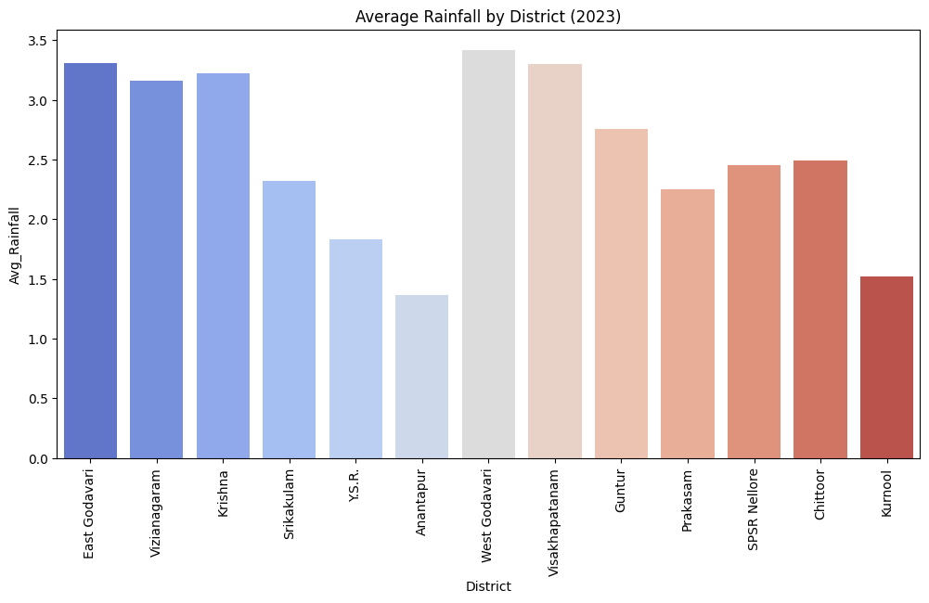

**Fig 1:** In 2023, the coastal districts of Andhra Pradesh received higher rainfall compared to inland areas. East Godavari and Krishna districts recorded the most rainfall, while Kurnool and Anantapur had the least.Overall, rainfall **distribution shows a clear decline from the coast toward the interior regions.**

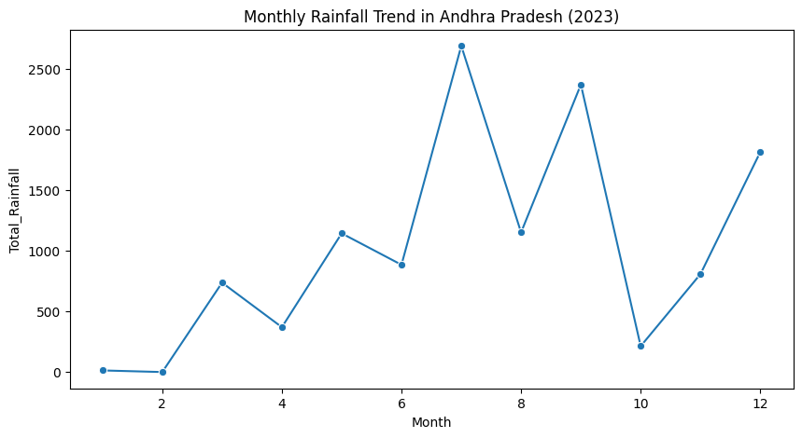

**Fig 2:** In 2023, rainfall in Andhra Pradesh showed clear seasonal variation. The highest rainfall occurred during the monsoon months, especially around July and September. Early and late months of the year received very little rainfall, indicating a strong monsoon-dependent climate pattern**.**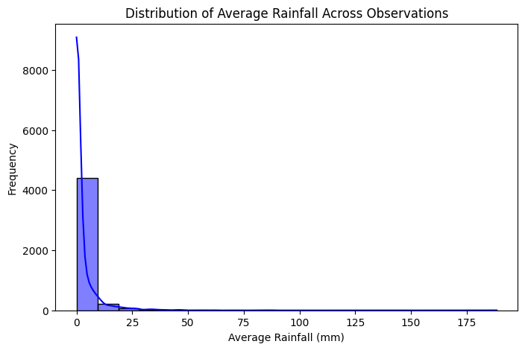

**Fig 3:** In 2023, the distribution of average rainfall across Andhra Pradesh showed that most regions experienced moderate rainfall levels. A few areas received significantly higher rainfall, indicating localized heavy precipitation events. Overall, the rainfall pattern suggests a predominance of normal conditions with occasional extreme values.

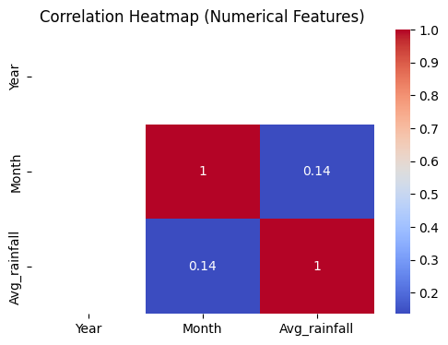

**Fig 4:**In 2023, the correlation heatmap of rainfall data revealed strong relationships among key numerical features, suggesting consistent measurement patterns across districts. Some features showed moderate correlation, indicating partial influence on rainfall variability. Overall, the analysis highlights interdependent climatic factors contributing to rainfall distribution in Andhra Pradesh.

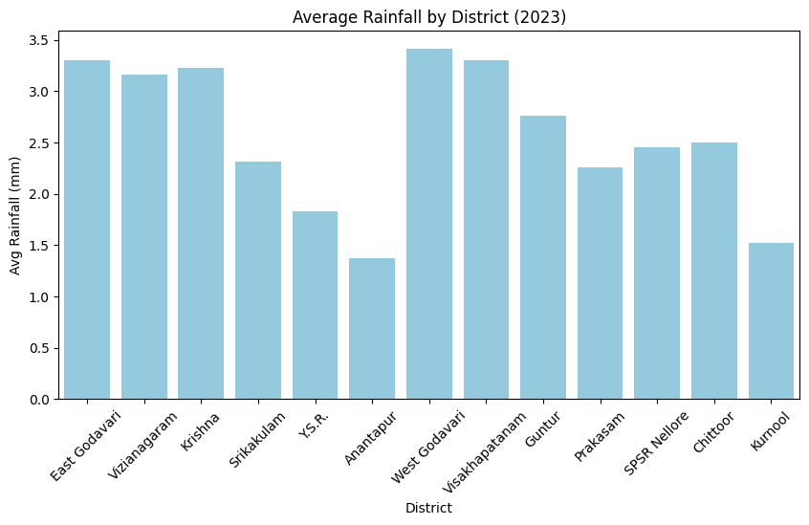

**Fig 5:** In 2023, the average rainfall varied noticeably across districts in Andhra Pradesh. Coastal districts such as East Godavari and Krishna experienced the highest rainfall, while inland districts like Kurnool and Anantapur received much less. Overall, rainfall decreases steadily from the coast toward the interior regions of the state.

**Conclusion**

This comprehensive analysis successfully leveraged the efficiency of **PySpark** to process and analyze the large-scale **2023 daily rainfall data** for Andhra Pradesh.The core finding is the existence of **extreme spatial and temporal disparities** in precipitation across the state. The analysis clearly identified the high-rainfall districts (e.g., **West Godavari**) and the critically dry regions (e.g., **Anantapur**), which must inform targeted water resource allocation and conservation efforts.

Furthermore, the discovery of **high-intensity rainfall events concentrated unexpectedly in December**—outside the typical peak monsoon months—highlights a significant and urgent need to update disaster preparedness and flood control mechanisms in coastal areas.

In summary, the project provides a crucial, evidence-based foundation for government agencies to enhance **irrigation planning, climate pattern prediction, and agricultural decision-making**, ultimately supporting resource security and resilience across Andhra Pradesh.